**IONOS SIM HF/VHF-UHF Channel Simulator**

**BUSY DETECT Busy Channel Detector**

**Instructions, Basic Documentation, and Specifications**

Ref: Software Beta revision 0.9.16 Rick Muething, KN6KB May 25, 2020

**1.0 Introduction:**  The Teensy **IONOS SIM** is an audio processing 1-4 path (ray) simulator that models standard HF and VHF/UHF propagation channels. It is intended primarily for modem and protocol design, analysis, optimization and comparison. It allows *non-radio* testing of protocols and modems using statistically standardized channels that would be almost impossible to achieve with normal “over the air” RF testing. The simulator is based on the well-documented Watterson model [ 1] used by many laboratory grade instruments costing many thousands of dollars.

**2.0 Basic Description:** The **IONOS SIM** Simulator is based on the low-cost but powerful Teensy 4.0 processor (<https://www.pjrc.com/store/teensy40.html>) and was developed using the Arduino platform and makes extensive use of the Teensy Audio DSP library <https://www.pjrc.com/teensy/gui/index.html> . The IONOS SIM software is released under the MIT Open Source License (see appendix). A simplified block diagram of the simulator is shown below in Fig 1.

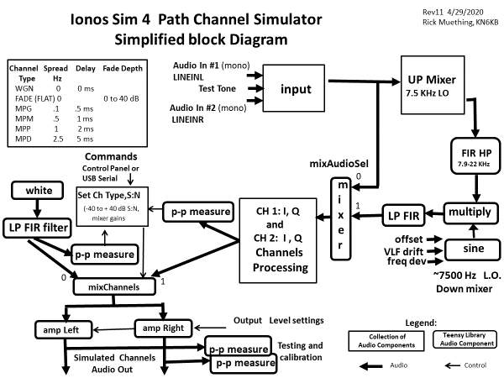

**Fig 1. Teensy IONOS HF/VHF Channel Simulator block diagram.**

[1] Watterson, C.C., J.R. Juroshek, & W.D. Bensema. 1970 Experimental confirmation of an HF channel model IEEE Transaction of Communication. Technology. Vol COM-18. Pp 792-803 Dec 1970

**3.0 Basic Layout:** The Basic layout of the Simulator is shown in Figs 2 & 3. The simplified user interface consists of just 2 rotary encoders (each with push action switch) and a small color graphics TFT display mounted in an ~ 4” x 6” customized PolyCase enclosure. Additional surface mount components are on the rear side of the PCB. The simulator is powered through its micro USB connector which also provides optional USB serial I/O for computer- controlled operation if desired. Audio input (2 mono channels) and audio output (2 mono channels) connections are made using standard 1/8” (3.5 mm) stereo phone jacks.

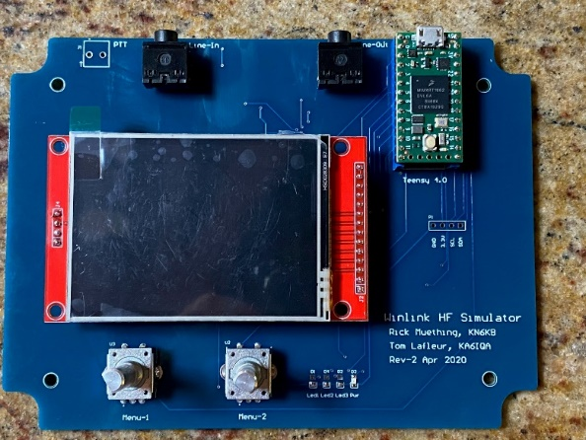

**Fig 2. Basic control/display layout (Rev 2 prototype) Schematic, PCB design, layout assembly and test by Tom Lafleur KA6IQA**

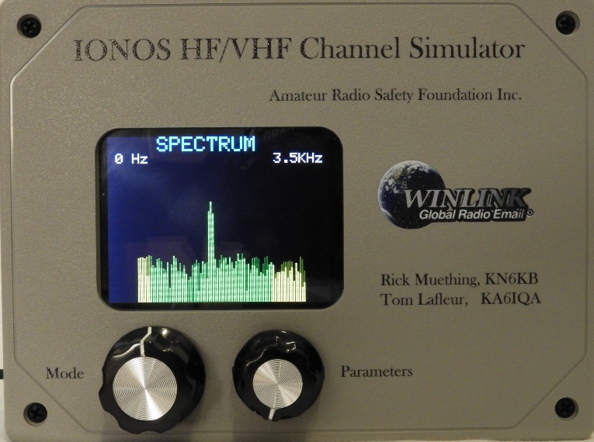

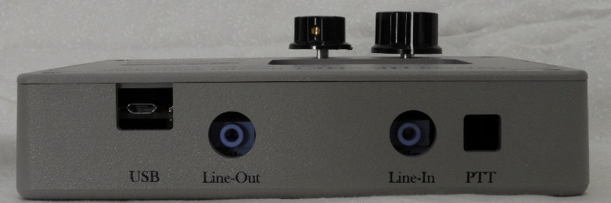

**Fig 3. Production Front Panel and side connections**

**3.1 Automated self test.** There is a simple mechanism for automated self-test and calibration verification. First connect the output jack to the input jack with a standard Stereo 1/8” (3.5 mm) 3 conductor male patch cord. This jumpers the CH1 and CH2 output amplifiers to the CH1 and CH2 input buffers. The self-test software will block the normal in to out connection to avoid oscillations and accurately measure the levels of the precision internally generated test signal and the injection of that signal into the inputs. This verifies: a) Connections and wiring to the output and input jacks, b) proper amplifier resistor values/tolerance, c) proper low frequency coupling capacitors, d) All Teensy Audio processing and DSP FIR filtering, e) Frequency response on both 3KHz and 6KHz bandwidths (Flat +/- .5dB). The self-test is also useful in setting up initial modem output levels.

**3.1.1 Running the Self Test.** With the patch jumper above in place, power on the IONOS Simulator by plugging in the USB port. The software and self-test software are already loaded. After the power on display of the current code revision (e.g. IONOS SIM 0.9.7 etc.) and serial number the display will enter the normal power on mode (WGN mode with S:N = 40 dB). Rotate the Mode (left hand encoder) knob 16 clicks CW to activate the TEST3K Sine: self-test. This will set up a 1548 Hz test sine wave at a specific amplitude and begin averaging the p-p (peak to peak) voltage readings at the input buffers (Ch1 in, Ch2 in) and output Amps (Ch1 Out, Ch2 Out). Averaging is used to increase resolution and after about 5 seconds the average measurements should stabilize to stable values (all values in p-p mv). If the values displayed are all green text, the measurements are with +/- .5 dB…the basic accuracy of the simulator. Any values in red text are outside the +/- .5 dB limit above. Different levels for Ch1 and Ch2 are used to verify there is no cross-coupling. The entire range of frequencies for the 3 KHz bandwidth can be tested by rotating the right hand (parameter) knob. Frequency range for the TEST3K will range from 86 Hz to 3182 Hz. During the test you can toggle to the Spectrum display by pushing down on the Mode (left hand) encoder. Pushing again will toggle back to the TEST3K display.

In a similar way rotating the mode knob CW one additional click (17 clicks from Power on WGN position) will enable the TEST6K test. It works exactly the same as the TEST3K but the frequency range spans 172 Hz to 6192 Hz. It exercises different FIR filters used in the 6 KHz bandwidth mode. Again, you may have to wait a few seconds for reading averages to stabilize. The 6 KHz mode swaps the Ch1/Ch2 amplitudes from the 3 KHz test insuring all paths are independent and work at full amplitude.

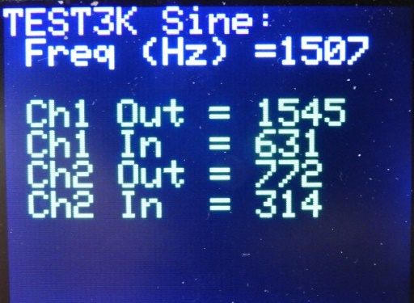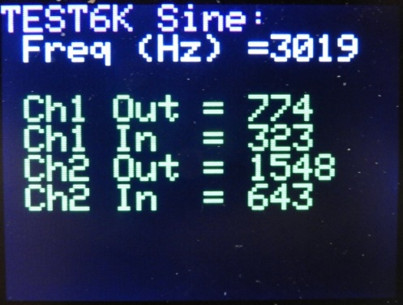

**Fig 4. Example Screens for TEST3K an TEST6K self-test and calibration verification.**

**Green text indicates parameter within +/- .5 dB and values can vary about 5% from those shown above.**

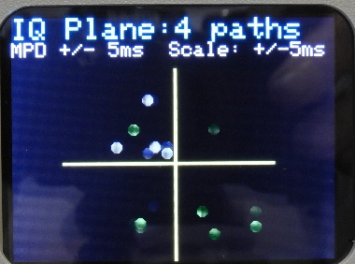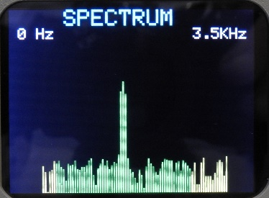**3.2 Getting Familiar with the controls and displays of IONOS SIM.** You can gain familiarity with the simulator without hooking it up to any modems or TNCs. An earphone (mono or stereo) plugged into the Ch1,2 output jack will be helpful. Upon power-up after plugging in to a +5 v powered micro USB port the TFT display will Activate and show IONOS SIM version xxxxx for four seconds along with an 8 digit hex serial number before going to the ***Basic Mode*** display. There it will show the current mode “WGN:” in blue text and the current parameter value for that mode which will be “S:N= 40 dB” in green text. Also shown in the WGN mode is the internal signal level (mv p-p) and the Crest Factor (CR) of the input. WGN (White Gaussian Noise) is the most basic mode and one that will be used often for setup and initial testing runs. Rotate the right hand encoder (parameter) CW or CCW to roll through the S:N options (-40 to +40 dB). The display of mode settings/parameters and text colors are similar for the 14 other modes shown in Fig 8. (The self-test modes TEST3K and TEST6K are shown in magenta to distinguish them from normal operating modes) Most modes and settings can be left at their power on defaults for basic testing. For modes WGN-MPP pushing down on the right encoder until it clicks will toggle the internal 1500 Hz test tone on/off. You should hear the tone in the earphone and see the simulator’s internal p-p level in mv shown on the screen. Adjusting the S:N lower should increase the noise. Most people can still hear the signal down to about -10 to -15 dB below the noise (all dB measurements and calculation are based on the operational bandwidth (3000/6000 Hz). In other modes pushing down on the right encoder will save the current mode parameter to EEPROM as the power on default value. For modes WGN-MPD pushing on the left encoder knob should switch the display to the ***Spectrum*** mode (3.5 or 6.5 KHz). There you should see the test tone and the background noise (white noise filtered to bandwidth) displayed. The vertical plotting scale of the spectrum analyzer is logarithmic and covers approx. 60 dB dynamic range. Each spectrum line (2 pixels wide for 0 to 3500 Hz) represents one ~43 Hz frequency bin. Toggle off the spectrum display with another push of the mode knob) to return to the ***Basic Mode*** display. Now select a multipath mode (say MPD for Multi Path Disturbed). Push the Mode (left) encoder once to switch back to the spectrum display. There you will see the impact the 4 ray multipath distortion created by the simulator has on the 1500 Hz test tone. MPD is a very poor channel and HF digital communications on this path are often impossible. Another push of the Mode (left) encoder will toggle to the ***IQ Plane*** display. This display shows dynamically how the 4 audio channels (In phase or ***I*** and quadrature or ***Q***) for two audio paths (4 total “rays”) are dynamically altered by the simulator. The display plots white and green “dots” corresponding to the calculated I & Q delay shifts for 4 audio rays on the IQ delay plane. The speed of the update is 32 x the delay spread for the channel modeled which meets the recommendation established by the CCIR/ITU. The IQ Plane plot *scale* remains constant at +/- 5 ms for all multipath modes. The values calculated by the simulator are based on a +/- 1 sigma normal (gaussian) distribution of the modeled channel’s delay spread. Pushing the mode (left) encoder once more should return you to the ***Basic Mode*** display. For most parameters (except S:N on WGN-MPD) you can push the parameter (right) knob to set the displayed value as the power on default (stored in EEPROM). You can explore the various other mode and parameter settings. There are no settings that will damage the Simulator but care should be taken when advancing the output volumes (CH1, CH2 OUT) levels which could result in loud levels to some earphones.

**3.3 Exploring the other modes and parameters for other testing.** While the WGN and Multipath channels are primarily used in HF Path simulation the simulator also supports functions useful in VHF/UHF path simulation. This testing is usually done using the standard WGN channel (across a range of S:N range of interest) modified with functions for VHF/UHF simulation. The primary ones of these are **FLAT fade** caused by multipath signal reception on FM and **FM Deviation** caused by transmitter/receiver drift or doppler shift. Figure 7 shows these modes and the parameter range of each. Again the 1500 Hz test tone can be used as a basic signal source and the Spectrum analyzer display to observe these effects just as was done in the basic HF modes. The fixed **OFFSET** mode can also be used to supply a small (+/- 200 Hz range) frequency offset to the audio input and this is helpful in testing/evaluating the ability of the modem to handle frequency tuning offsets primarily on HF SSB transmission. Finally, the simulator also supports a 6 KHz bandwidth mode. Though not normally used on amateur HF transmissions this can be used in modeling wider band audio channels used on VHF and UHF such as 9600 baud packet or VARA VHF. In 6 KHz bandwidth mode the simulator’s internal FIR filters are all switched to a 6300 Hz range and the Spectrum display is modified to cover the full range 0 to 6500 Hz. In the 6500 Hz spectrum mode each ~43 Hz bin is represented by a one-pixel-wide vertical rectangle spaced by 1 pixel of black.

**3.4 Internal Signal Levels and Crest Factor.**  The simulator also provides a continuous display of its internal signal level (mv p-p) in display modes WGN through MPD. This is designed to aid in setting modem output levels and Simulator Input gain (CH1 IN, CH2IN) to appropriate operating levels. The full internal signal range of the simulator is 0 to 2000 mv p-p but normally signal levels should target a range of 300 to 1700 mv p-p. The p-p level measured value is shown in green when it is between these limits or red if outside. Also on a WGN channel the Crest Factor (CF) of the input waveform is computed and displayed. The CF indicates the ratio of peak to average (rms) level. For reference a pure sine wave has a CF = 1.41.

**4.0 Basic Setup and Connections for using the Simulator.** The simulator can be used to model the paths for non ARQ (one direction) or ARQ half-duplex or full duplex connections. With its’ internal audio CH1 and CH2 mixing a *single* **IONOS SIM** can handle *both* directions of a half-duplex ARQ connection providing symmetric channel modeling (same channel for Modem 1 to Modem 2 and Modem 2 to Modem 1). Figs. 5 and 6 show the connections for both half duplex and full duplex channel modeling.

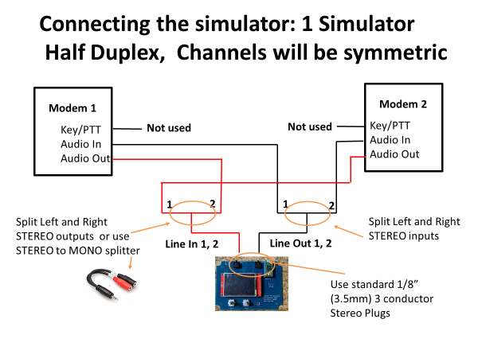

**Fig 5. Basic Half Duplex, symmetric channel setup with one IONOS SIM.**

(note: Stereo isolation transformers can be used if ground loops affect audio quality)

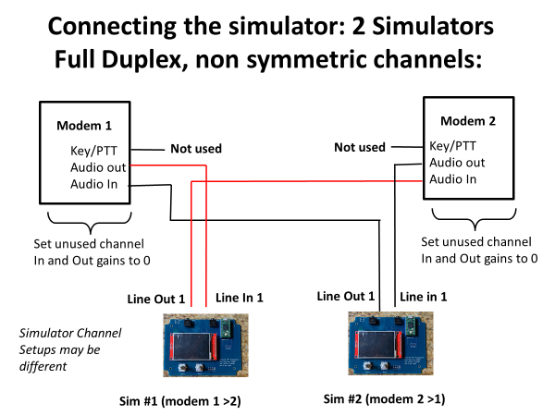

**Fig 6. Full Duplex, non-symmetric channel setup using two IONOS SIMs**

(note: Stereo isolation transformers can be used if ground loops affect audio quality)

**4.1 Audio Levels.** For proper operation the simulator must supply non-saturated, undistorted audio *to* the modems and receive correct level audio *from* the modems. The Simulator has 4 audio gain/output level controls that allow a wide independent adjustment for CH1 and CH2 input and CH1 and CH2 Outputs. There are probably also other gain adjustments (hardware or software) on the *modem* in and out audio. The optimum settings are those output levels that allow the modem to be driven with the required signal without overdriving or clipping *and* with input levels and gain settings that allow the simulator to process audio in its normal range (300 – 1700 mv p-p). The p-p level readouts shown in Modes WGN thru MPD show the actual measured pp levels. Take time to adjust and note the settings [Modems 1 and 2 inputs and outputs, Simulator CH1 and CH2 Inputs and Simulator CH1 and CH2 outputs] so they can be easily setup again. *(Simulator gain settings can be saved to EEPROM by pushing on the right (parameter) encoder when the gain setting is displayed).* Input gains and output levels are adjustable over a wide logarithmic range (0,.1,.2,.5,1,2,5,10,20,50,100). If an input gain or output level is too large for the dynamic range of the simulator (levels shown in RED) it may cause clipping and distortion of the audio signal. One suggested mechanism for setting the proper level signal into the simulator is:

1)Connect *one* modem output to the simulator (In1 or In2). If there is any noise or hum introduced by ground loops using a stereo line isolator (transformer) in the audio to/from the simulator has been shown to help.

2) Set the simulator up for the desired channel mode (WGN through MPP). This will show the input signal p-p readings on the Ch1 In or Ch2 in lines.

3) Adjust the output of the *modem* to fall within a range of 300 – 1700 (mv p-p). The level can be controlled by *EITHER* the modem’s output level adjustment or CH1 or CH2 in adjustment on the simulator.

4) The simulator Out gain settings (CH 1 OUT or CH2 OUT) can then be used to make simulator *output* adjustments as needed for proper modem input level. There may be additional modem input gain settings on the modem.

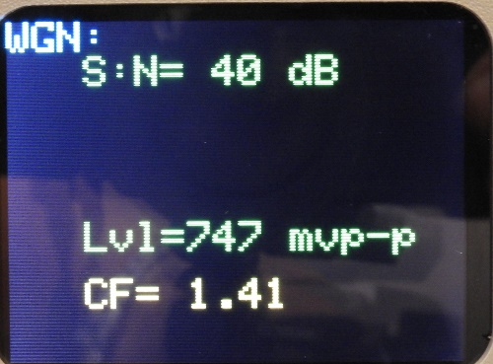5) Repeat steps 1-4 for the other modem input and output. Make test runs using the WGN mode with 20 or 30 dB S:N to verify proper setup and operation before making any extensive measurement runs. Document all the levels used to make repeated setups easier and consistent and if desired save the Simulator Input Gain and Output Level settings to EEPROM. *Note: The modem’s input and output levels may not be the same as normal operation with a transceiver since the audio input requirements and output levels from the transceiver may be different.*

**Fig 7 Level display and Crest Factor Computation WGN Mode**

**5.0 Manual User Interface (Right & Left Encoders).** The primary user interface consists of 2 rotary encoders with push capability and a 320x240 pixel color graphics display. The Encoders allow selection of basic Modes (left encoder) and parameters (right encoder). The left push function toggles less used functions on/off : (**Spectrum Plot**, **IQ Plane** **delay plots**). The right encoder push function togles a built in 1.5 KHz oscillator on/off for testing or saves power on default parameter values to EEPROM.

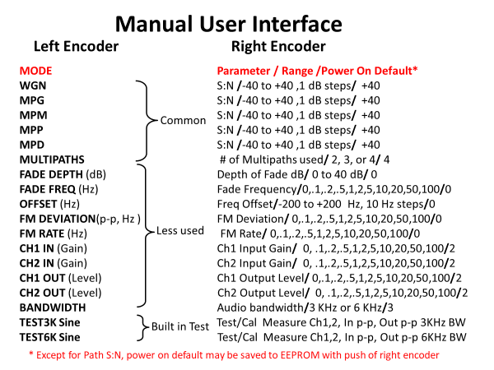

**Fig. 8. Manual User Interface Encoders 1 and 2.**

**6.0 Computer interface.** Although most users will find the encoder interface above simpler and easier to use an alternative USB serial interface (9600 baud) is included that can allow more sophisticated and automated testing using short ASCII commands through the Simulator’s serial USB port. This will require some user supplied control program that sets up the simulator and modem, runs a session for a specific path type and S:N, and computes and saves performance data (e.g. average net bytes/minute transferred). This can save much time if a large number of simulations are to be run. Each command sent by the computer to the simulator must be sequenced by the correct response [ OK(Cr)] from the simulator. The commands are case insensitive standard ASCII as shown in Fig 9. If a syntax, spelling error, or parameter out of range is received by the simulator a [“?” (Cr)] is returned. The BUSY command is used for a busy detector function (section 7). The commands in Fig 8 correspond to mode and parameter settings of rotary encoders 1 and 2.

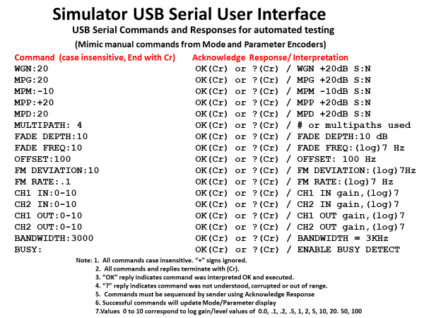

**Fig 9. Serial Commands for Simulator Control**

(note: Command “**BUSY:**”) is normally not used with the Simulator. It switches the **IONOS SIM** to a **BUSY DETECT** mode. See section 7.0)

**7.0 Basic Application of the Simulator for HF and VHF/UHF use**

The use of the IONOS Sim is relatively straight forward but some care is required in setting up test to get consistent and representative test results.

**7.1 Test Parameters.** Most Simulation runs compare/plot net throughput (after all retries for ARQ modes) vs a specific path type and range of S:N (e.g. MPG over +20 to – 10 dB). For comparison several graphs are often shown on one chart. To obtain accurate and repeatable results requires sending sufficient data over a fairly long session (at least 5 minutes and often over 10.). This is because of the nature and designed randomness of the channel modeling and the adaptation to changing channels used by adaptive modems. White Noise and channel delay values are standardized random or normal (gaussian) distributions so successive runs with the same test data and parameter values normally will vary somewhat.

**7.2 Test Examples for HF and VHF Testing of different protocols.** Fig 10 below plots the performance in net bytes/minute of 5 HF protocols over a S:N range +20 to -5 dB using a Multi Path Good (MPG) channel done by Tom Whiteside N5TW using the IONOS SIM simulator. The drop off of throughput vs S:N is normal and gives a good indication of how the protocol can be expected to work at a given received S:N on a MPG channel.

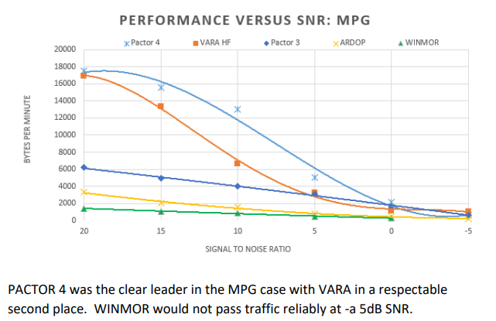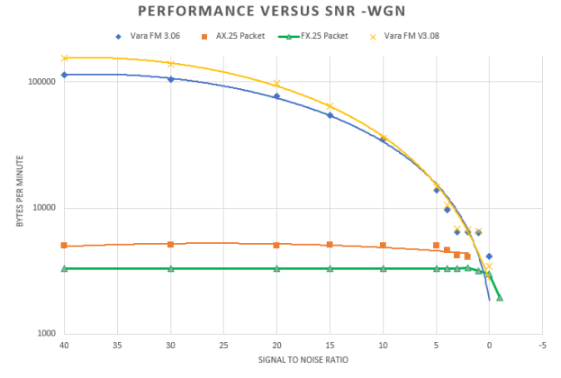

**Fig 10: 5 HF Protocols over +20 to -5 dB S:N MPG**  **Fig 11: 4 VHF FM Protocols over +40 to -3 dB S:N**

Figure 11 shows a simulation for 4 different VHF FM protocols. Since these protocols can use wider bandwidth “audio” to the FM Modulator the IONOS SIM simulator is set for its 6KHz bandwidth option. More details on Tom’s extensive simulation efforts using the IONOS SIM simulator can be found at <https://winlink.org/content/ionos_simulator>

To collect repeatable and representative data it is necessary for the simulations runs to be long enough to accommodate modems/protocols that use adaptive modulation. Each “dot” or symbol in the above plots represents a typical simulator run of 10+ minutes. To aid making many long runs when extensive testing is anticipated the IONOS SIM simulator can be computer controlled using the commands shown in Fig 9. These example simulation cases and runs highlight why trying to obtain this kind of test accuracy and repeatability is so difficult using normal “over-the-air” radio testing.

**8.0 Busy Channel Detector operation (experimental)**

This function rewires (via software) the audio path flow and DSP processing of the **IONOS SIM** to perform a **BUSY DETECT** function. The purpose of this function is to provide improved automatic (computer controlled ) busy channel detection capability for automated stations by performing accurate and rapid spectrum analysis over a specified frequency band of interest. This function is in development and optimization of the performance (speed and accuracy) of the busy detector algorithms continues. This function is NOT intended for manual user control so is totally commanded from serial commands sent between the simulator/busy detector from a host computer. Figure 12 summarized the basic commands of the **BUSY DETECTOR**.

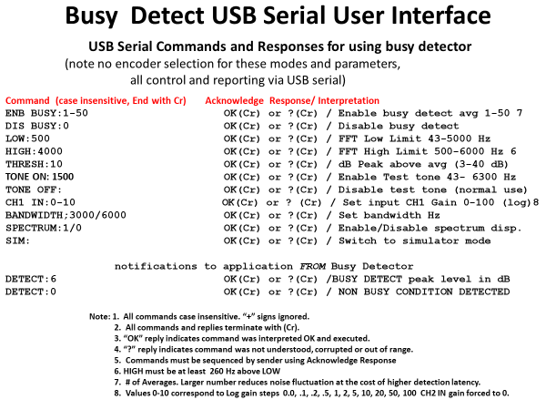

**Fig 12. BUSY DETECT serial commands and responses.**

There is one serial command “**BUSY: (Cr)**” issued from the **IONOS SIM** serial interface to *enter* into the **BUSY DETECT** mode. Once this command is received the screen displays **BUSY DETECT** and the revision number for 3 seconds and acknowledges by an OK (Cr) response. Then the commands, responses and DETECT: notifications in Fig 9 are operational. Since all operation of the **BUSY DETECT** function are controlled by serial commands to/from to the host control program there is no encoder mode or manual entry parameters used in **BUSY DETECT** mode.

**8.1 BUSY DETECT Command Details.** This section documents the command function use in the busy detector.

**ENB BUSY:n** 1 <= n <= 50 Enable Busy detection using FFT averages. Each FFT acquisition and average takes approx. 11 ms. This allows trading off noise suppression by averaging (larger number of averages) vs decision time. Typical values range between 10 and 30 averages.

**DIS BUSY:0** Disables busy detection

**LOW: n** 43 Hz <= n <= 5000Hz Sets the low frequency limit for the frequency band of interest.

**HIGH: n** 500Hz <= n <= 6000 Hz Sets the high frequency limit for frequency band of interest. Note: HIGH value must be at least 260 Hz above LOW value. **IMPORTANT:** ***BOTH*** the HIGH and LOW frequencies should pass to the busy detector without attenuation by any receiver filters. This is easily observed by looking at the spectrum display using the **SPECTRUM:1** command. There must be some yellow spectrum lines showing in the spectrum both at the high and low ends of the frequency band of interest. Signals in the yellow spectrum region ***ARE NOT*** considered by the busy detect algorithms.

**THRESH: 3 to 40 (dB)** Sets the detection threshold in dB above the averaged bins. A lower number (more sensitive) will usually require a higher number of averages in **ENB BUSY:n** above. Each average takes approximately 11 ms so there is a tradeoff in sensitivity vs response time. Typical thresholds are 5-20 dB. With moderate averaging (e.g. 15-20) it should be possible to detect a carrier at approximately -10 to -15 dB below the noise with few false detects. Note this will still be visible on the spectrum display since it displays S+N to N.

**TONE ON: n** Enable the test tone at frequency n Hz. 43 Hz <= n <= 6300 Hz

**TONE OFF:** Disable the test tone.

**CH1 IN:** **n** Set Input gain on Audio CH1 0 <= n <= 10. This corresponds to a gain factor of 0,.1,.2,.5,1,2,5,10,20,50,100. Audio CH2 Input Gain is forced to 0. Excessive gain will cause clipping and distortion inside the busy channel detector. **IMPORTANT:**  The input level to the busy detector is a function of the audio output of the receiver ***and*** the **CH1 IN:** gain above. It is not critical as long as spectrum lines are showing at the bottom of the display and there is no clipping of the audio level. The Receiver AGC should normally be set to FAST to MEDIUM and the bottom level “grass” of the spectrum on a quiet channel should be set to approximately the lower 25% of the spectrum amplitude.

**BANDWIDTH: n** Set the Busy detector bandwidth. n = 3000 or 6000 Hz.

**SPECTRUM: n** Enable (n=1) or Disable (n=0) Spectrum Display.Note on the spectrum display: Signals outside the frequency band of interest (below LOW or above HIGH above) are plotted in yellow. Non-busy conditions will plot the frequency band of interest in green. A busy detection will plot the frequency band of interest in red. Note the spectrum display adds approximately 200 ms to the processing time so the spectrum display should be disabled (**SPECTRUM:0**) once levels have been set up when operating under computer control.

**SIM:** Normally not used. Leaves the **BUSY DETECT** mode and returns to the **IONOS SIM** mode.

**8.2 BUSY DETECT automated responses.** There are two automated responses from the BUSY DETECT that are issued automatically upon entering or leaving a channel busy condition. Responses are asynchronous and need not be acknowledged by the Host.

**DETECT:** **n** 3 <= n < 40. A busy condition is detected that identifies a signal within the range of LOW to HIGH (above) that is >= the threshold value set with **THRESH:n** (above). n is in dB. Signals outside the region of interest (LOW TO HIGH) are ignored.

**DETECT: 0** Indicates a non-busy condition is detected (after appropriate averaging) There is a small hysteresis used that requires the **DETECT:0** to be sent ***only*** after the busy detector sense a level 2 dB or more *below* the programmed **THRESH:n** level.

**8.3 Basic Description of the Busy Detector Algorithm.** The busy detector does not try to interpret or in any way decode the signal in the band of interest. That would be a very complex task with significant DSP loading and complex decoding software. It would also limit sensitivity, require continual updating for new modes and significantly lengthen the detection time. Rather the algorithm relies (much like the human ear) on detection of the average energy received in each of the ~43 Hz FFT frequency bins within the spectrum of interest. (Between **LOW** and **HIGH** frequencies above). The algorithm averages each of the bins as received (rolling average implemented using IIR filters) to reduce the bin fluctuations due to noise. It then scans the frequency band of interest for narrow (~260Hz wide) *peaks* or *dips* in the spectrum lines. This mechanism allows detection of both narrow modes (e.g. CW, RTTY, PSK, JT etc.) and wider modes (e.g. SSB Voice, Pactor, VARA, FAX, WINMOR etc.) By allowing setup via commands (e.g. **ENB BUSY:n**, **THRESH:n**, and frequency detection range **LOW:n**, **HIGH:n**) the bandwidth, sensitivity and response time can be quickly customized for frequency band and receiver bandwidth during scanning operations. As operating experience is gained improvement in the sensitivity and accuracy of the **BUSY DETECT** algorithms is anticipated.

**IONOS SIM HF/VHF Channel Simulator Specifications** Rev 1.8 May 15, 2020

**Description*:*** *IONOS SIM* is a self-contained audio DSP based ionospheric simulator based on the Watterson Model [1]. It uses the Teensy 4.0 CPU (ARM Cortex-M7 processor at 600 MHz) and Teensy Audio DSP Library. The MIT open source licensed software (see appendix) was developed on the Arduino platform.

**Primary Use:** The development, characterization, maintenance and comparison of HF and VHF/UHF modems and protocols including “sound card” modems and protocols.

**Channels Modeled:** WGN (**W**hite **G**aussian **N**oise: Spread 0 Hz, Delay:0ms); , MPG (CCIR **M**ulti**P**ath **G**ood) Spread .1 Hz, Delay .5ms ; MPM (CCIR **M**ulti**P**ath **M**oderate) Spread .5Hz, Delay 1ms; , MPP (CCIR **M**ulti**P**ath **P**oor) Spread 1 Hz, Delay 2ms; MPD (**M**ulti**P**ath **Di**sturbed) Spread 2.5 Hz, Delay 5ms; Flat Fading 0-40 dB Fade, (Rate .1 to 100 Hz); Static Freq offset +/- 200 Hz; Slow FM deviation +/-.1 to 100 Hz, FM Rate .1 to 100 Hz. Multipath: (2,3 or 4 channels) Delay update rate: 32x spread above. (CCIR/ITU recommendation)

**Audio Paths:** WGN: 1 path. Multipath: selectable 2,3 or 4 channels (rays). Input to Output Delay: ~4-16 ms.

**Connections Modeled:** 1 Simulator: Half duplex, both sides, symmetric channel models. 2 Simulators: Full Duplex both sides: symmetric or asymmetric channel models.

**Bandwidths:** 3KHzBW:40Hz - 3.3 KHz, 6KHzBW:40Hz - 6.3 KHz. Ripple < +/- .5dB **Sampling rate:** 44.1 KHz

**Noise modeling:** WGN filtered to 3 KHz or 6 KHz bandwidth. S:N -40 to +40 dB, 1 dB steps.

**Crest Factor Measurement :** Input signal Crest Factor is computed and displayed in WGN Mode.

**Inputs:** Ch1, Ch2 via standard Stereo 1/8” (3.5 mm) jack. AC coupled. Input protection. Impedance > 50KOhms. Input gain control .1 to 100 adjusts internal level to 300 – 1700 mv p-p.

**Outputs:** Ch1, Ch2 via standard Stereo 1/8” (3.5 mm) jack. AC Coupled. Short circuit protection. Impedance 150 Ohms. Output level control sets output level 100 to 2000 mv p-p.

**Power Required:** Nominal 5 v (internally reg. to 3.3 V) via micro USB connector. ~ 200 ma.

**Display:** 320 x 240 pixel color TFT for Text and Graphics. 2.4”x 1.8” (60mm x 45mm)

**Operating and Display Modes:** Self-test and calibration verification; Set modes and parameters; Spectrum Display (3 & 6 KHz), ~60 dB dynamic range; Multipath dynamic IQ (2,3, or 4 channel) delay plot.

**User Parameter and control:** Two Incremental encoders (Mode, Parameter) each with push toggle functions. Parameter default values can be saved to EEPROM. USB serial ASCII commands for automated operation.

**Size:** 6.1” (155 mm) L x 4.7” (120 mm) W x 1.4” (36 mm) H (excluding knobs).

**Built In Test:** Built in Test (TEST3K, TEST6K) Tests and confirms Input to output continuity, Functions and Calibration accuracy +/- .5 dB in WGN mode across 3000 Hz or 6000 Hz spectrum.

**Alternate Functions:** Integrated Busy Channel Detector (experimental). Uses only serial USB ASCII command interface with host program.

[1] Watterson, C.C., J.R. Juroshek, & W.D. Bensema. 1970 Experimental confirmation of an HF channel model IEEE Transaction of Communication. Technology. Vol COM-18. Pp 792-803 Dec 1970

**APPENDIX:**

Copyright (C) 2020  Amateur Radio Safety Foundation Inc. (ARSFI)

Licensed under the MIT Open Source Initiative.

Permission is hereby granted, free of charge, to any person obtaining a copy of this software and associated documentation files (the "Software"), to deal in the Software without restriction, including without limitation the rights to use, copy, modify, merge, publish, distribute, sublicense, and/or sell copies of the Software, and to permit persons to whom the Software is furnished to do so, subject to the following conditions:

The above copyright notice and this permission notice shall be included in all copies or substantial portions of the Software.

THE SOFTWARE IS PROVIDED "AS IS", WITHOUT WARRANTY OF ANY KIND, EXPRESS OR IMPLIED, INCLUDING BUT NOT LIMITED TO THE WARRANTIES OF MERCHANTABILITY, FITNESS FOR A PARTICULAR PURPOSE AND NONINFRINGEMENT. IN NO EVENT SHALL THE AUTHORS OR COPYRIGHT HOLDERS BE LIABLE FOR ANY CLAIM, DAMAGES OR OTHER LIABILITY, WHETHER IN AN ACTION OF CONTRACT, TORT OR OTHERWISE, ARISING FROM, OUT OF OR IN CONNECTION WITH THE SOFTWARE OR THE USE OR OTHER DEALINGS IN THE SOFTWARE.